**Download links for MySQL Software:**

* MySQL download page for windows:
* <https://dev.mysql.com/downloads/windows/installer/8.0.html>
* Other Operating Systems:
* <https://dev.mysql.com/downloads/mysql/>

**Installation Steps (After double Clicking the download file):**

**1**

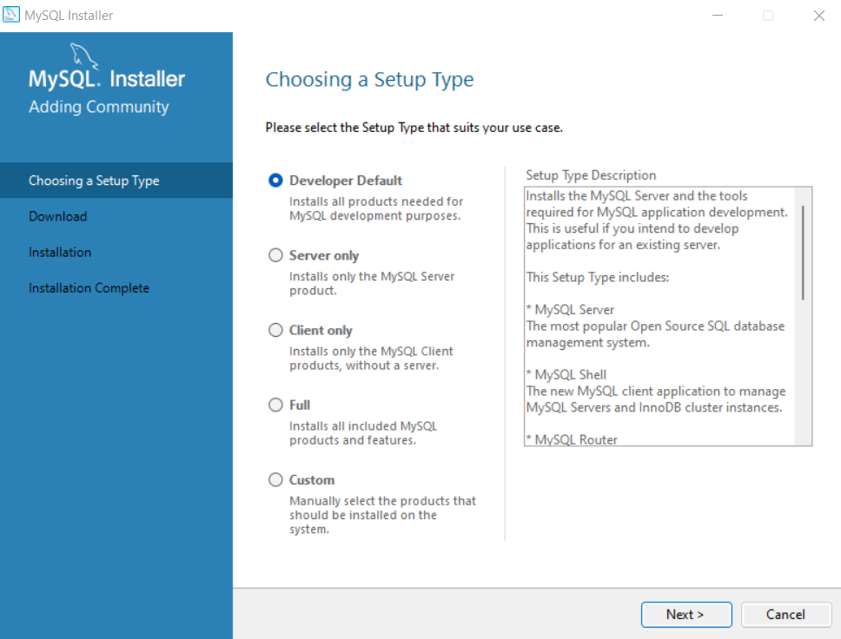

**2**

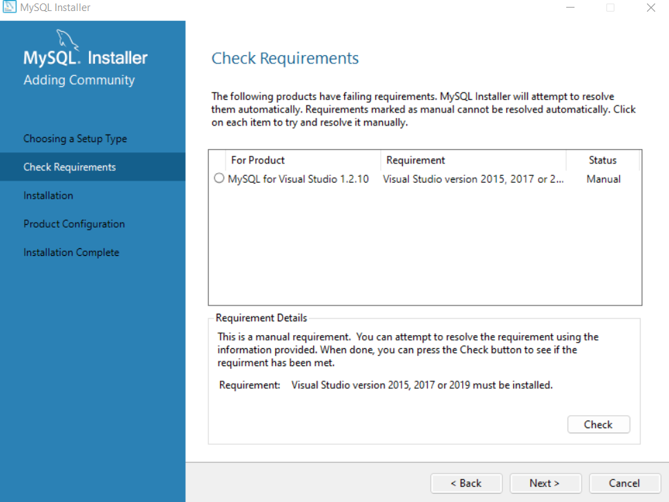

**3 Execute**

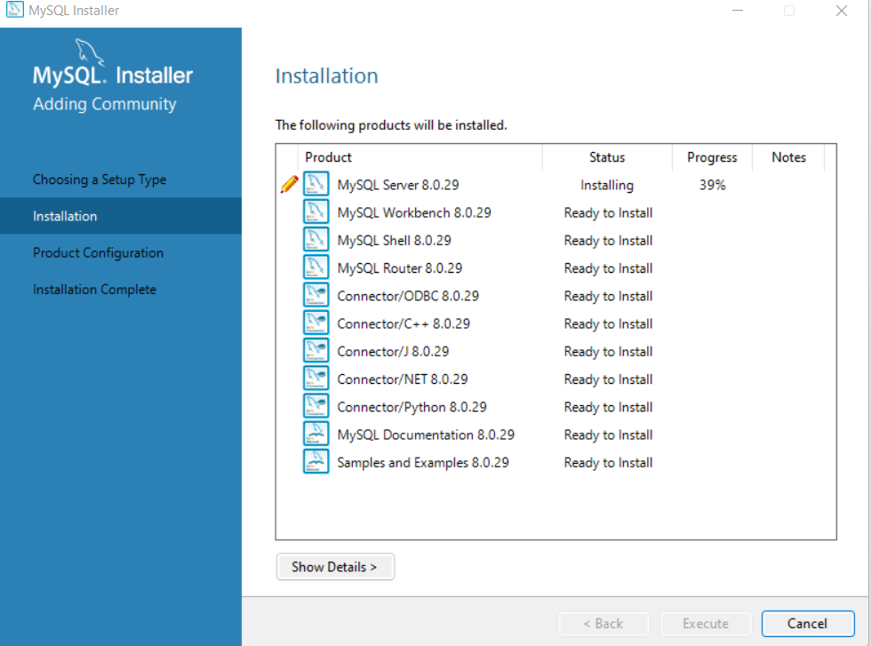

**4**

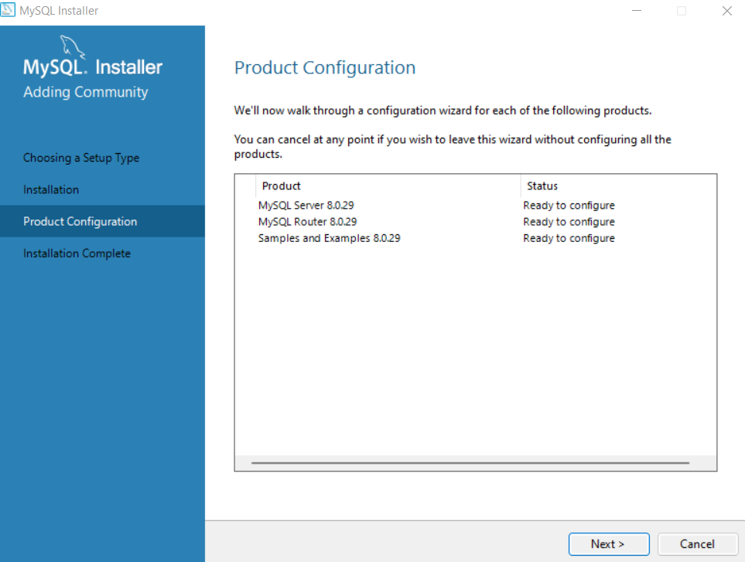

**5**

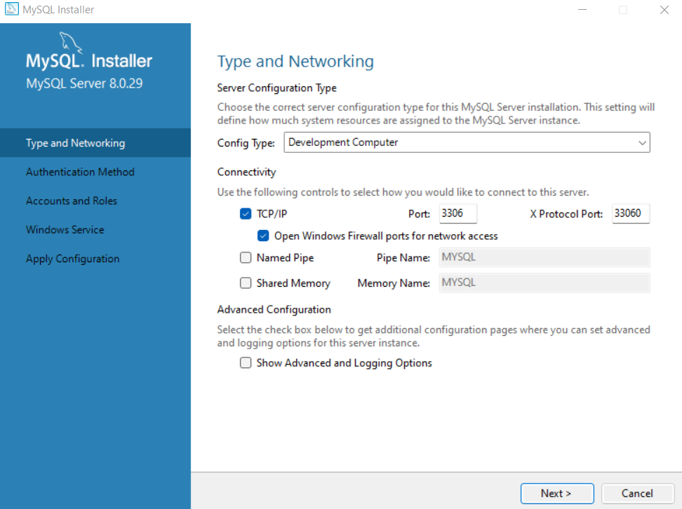

**6**

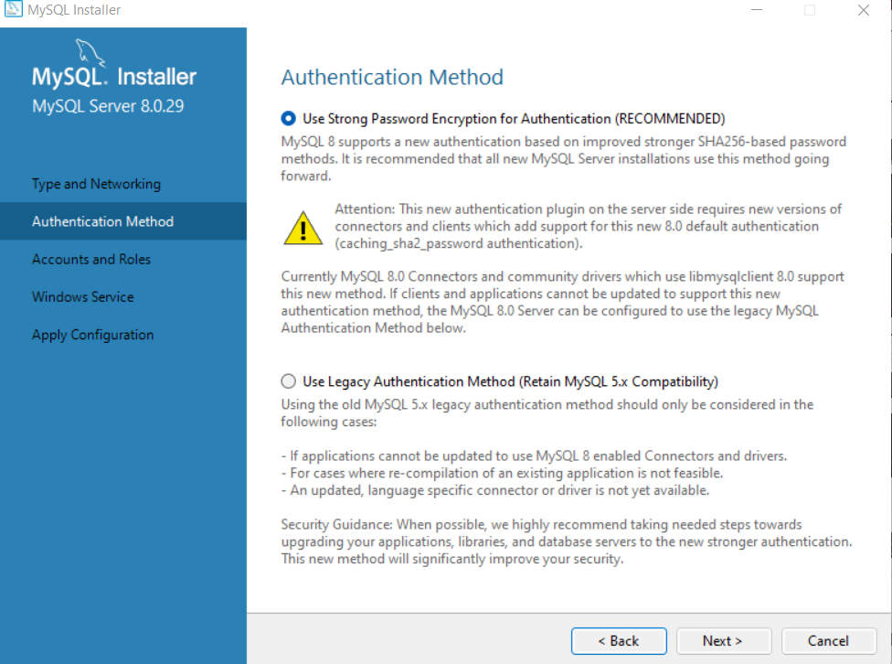

**7 root**

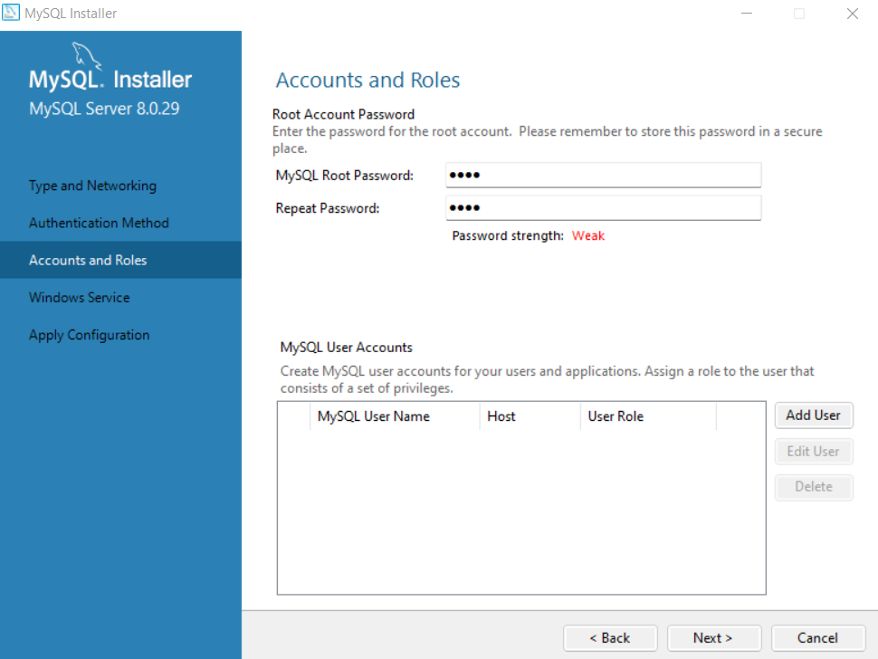

**8**

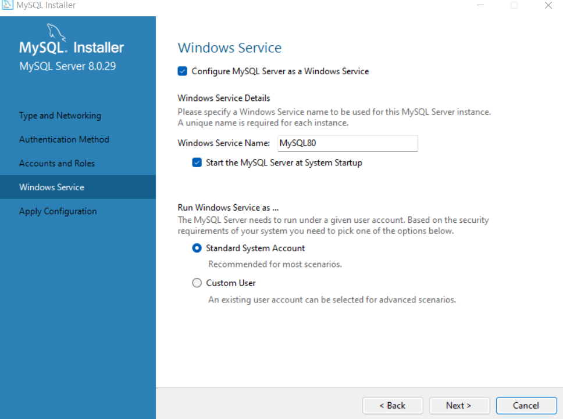

**9**

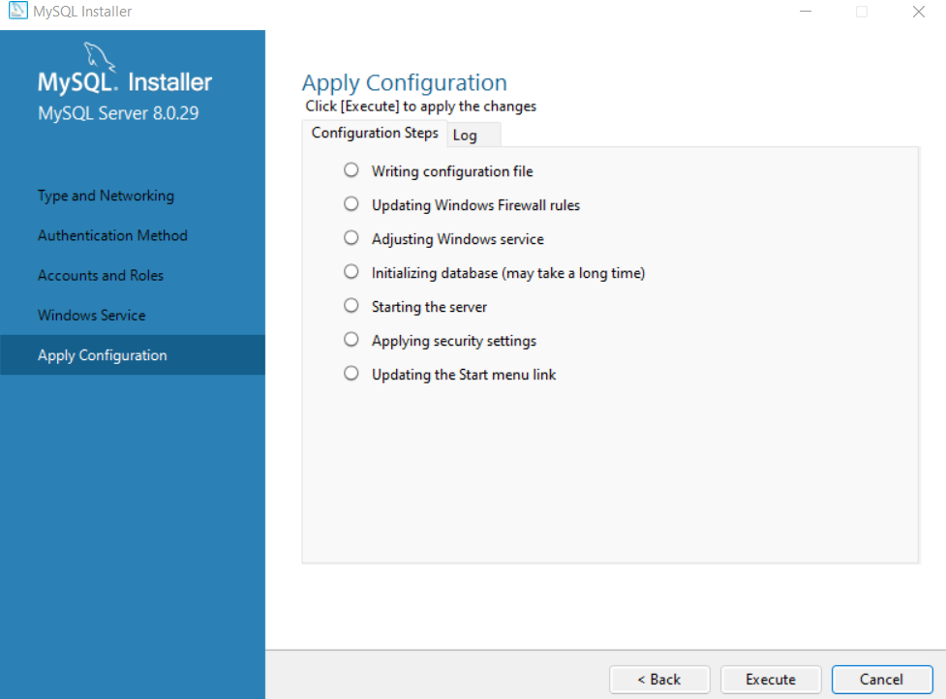

**10**

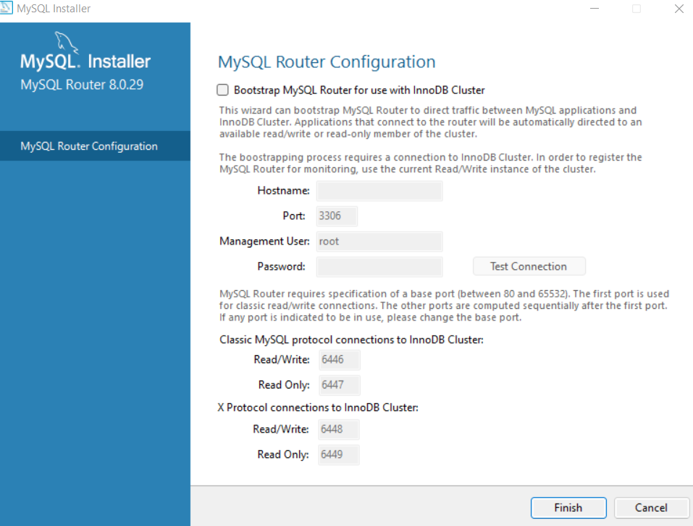

**11 enter password**

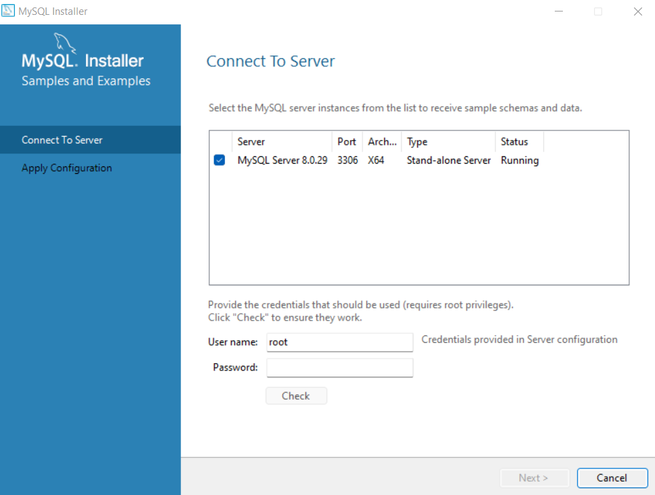

**12**

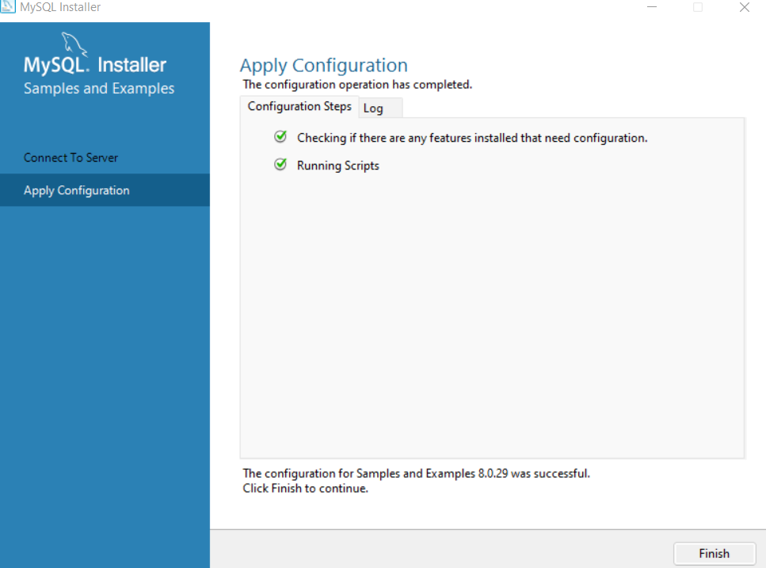

**13**

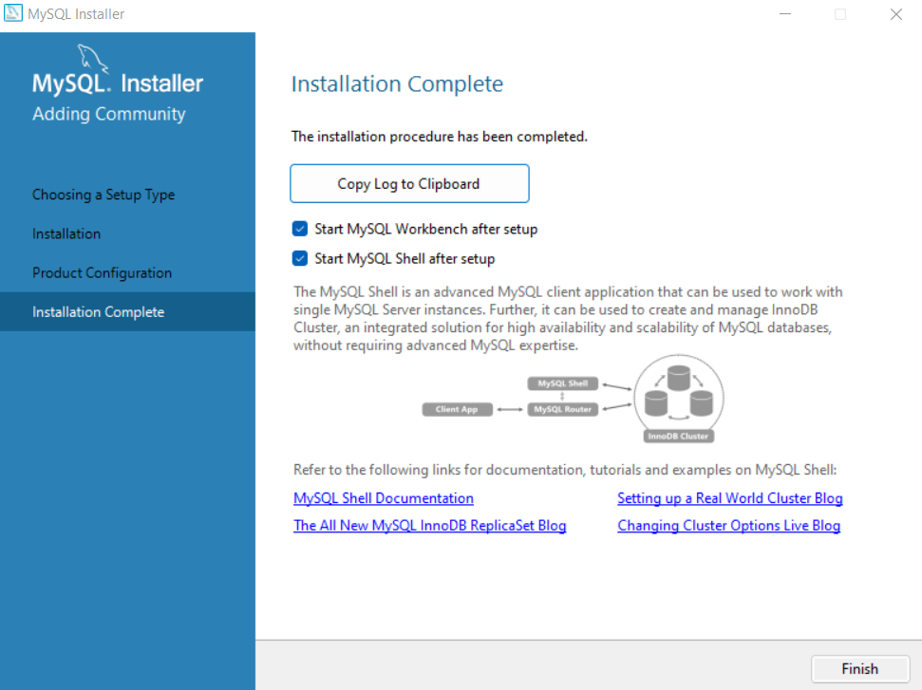

**FINISH**